

<https://vi.pngtree.com/freepng/school-student-illustration-student-pencil-male-student-hand-drawn-illustration-cartoon-style_3932877.html>



<https://vn.lovepik.com/image-828842672/school-boy-girl-pupil-schooling-cartoon-vector-elements.html>

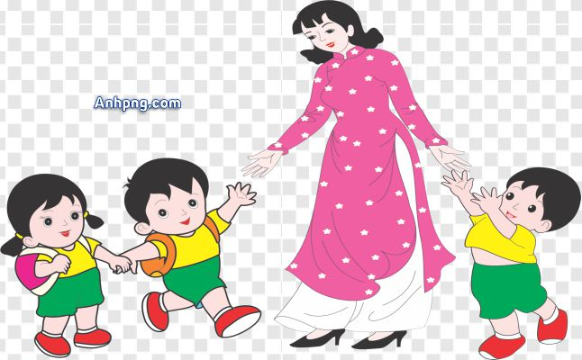

<https://www.anhpng.com/2022/09/anh-png-co-giao-va-hoc-sinh-mam-non-12.html#gsc.tab=0>

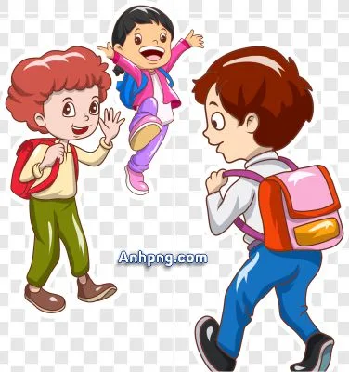

<https://www.anhpng.com/2022/09/anh-png-hoc-sinh-mang-cap-en-truong-16.html?m=1#gsc.tab=0>



<https://vi.pngtree.com/freepng/cartoon-little-boy-studying-on-the-desk_8674620.html>



<https://www.vecteezy.com/vector-art/23128999-character-student-back-to-school-university-concept-vector-illustration>

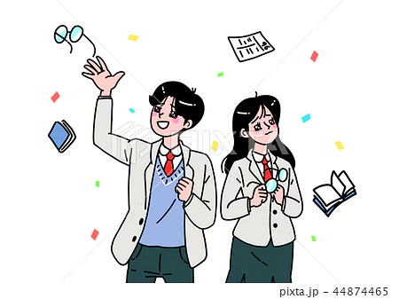

<https://www.pixtastock.com/illustration/44874465>

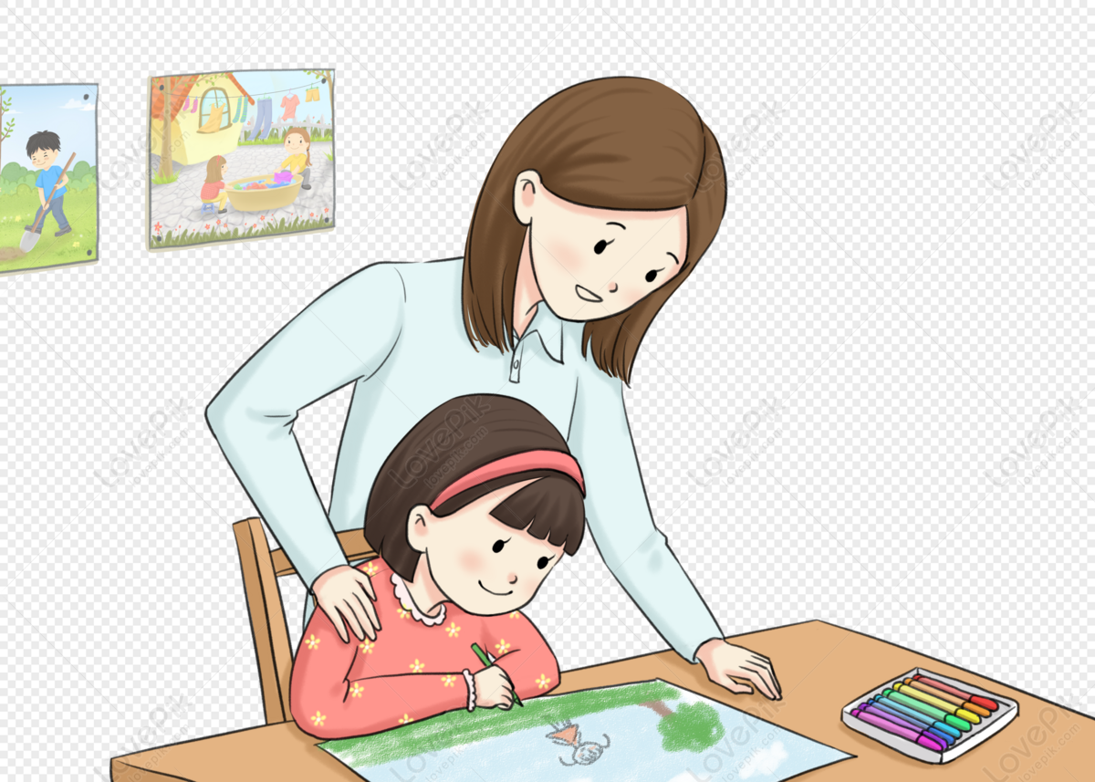

<https://lovepik.com/image-400511485/a-teacher-who-teaches-students-to-draw-pictures.html>

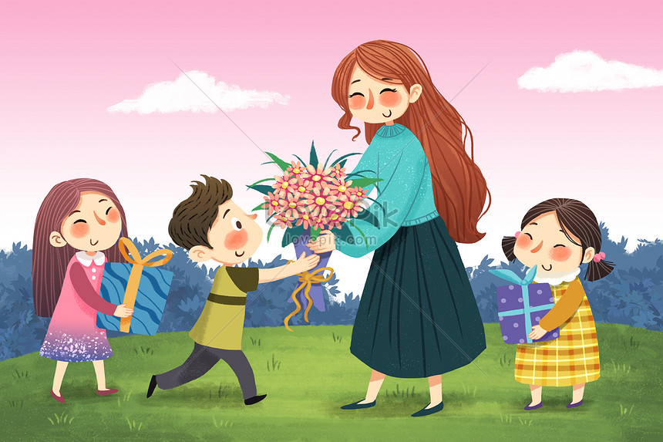

<https://lovepik.com/image-401600962/teacher-teacher-student-illustration.html>

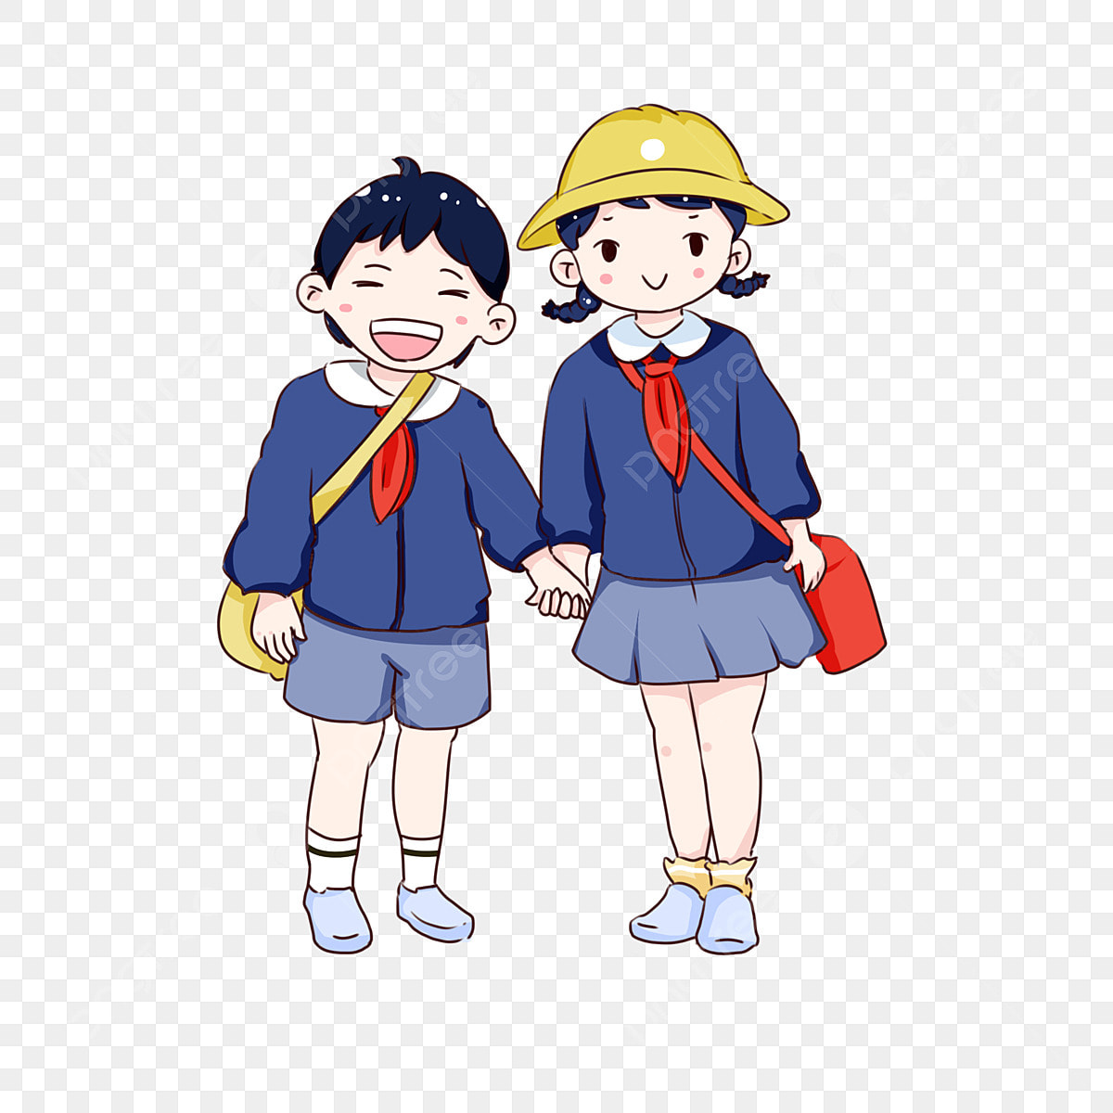

<https://vi.pngtree.com/freepng/hand-drawn-cartoon-schoolchildren-going-to-school-on-school-day-back-to-school-blue-school-uniform-cute-q-version-of-primary-school-students_3848611.html>

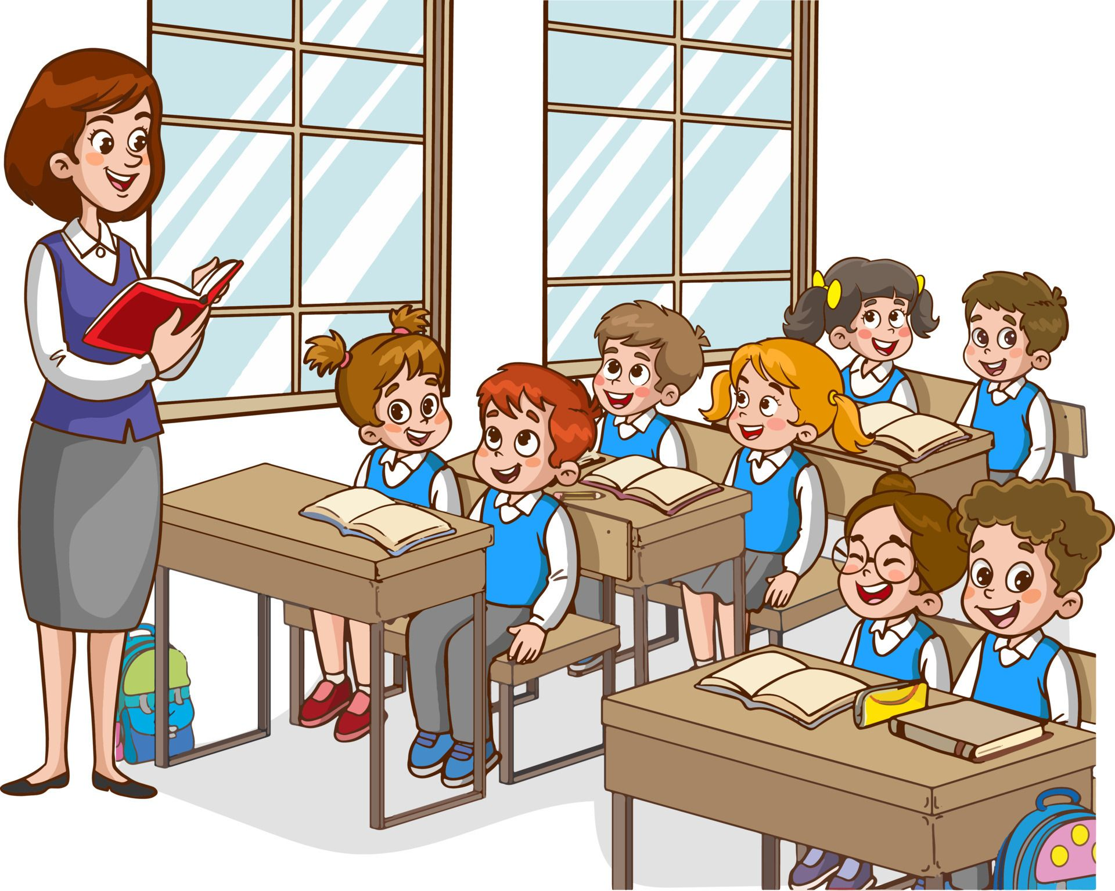

https://www.pinterest.com/pin/illustration-with-kids-and-teacher-in-a-classroom-education-illustration-vector-interior--16536723624665308/

11

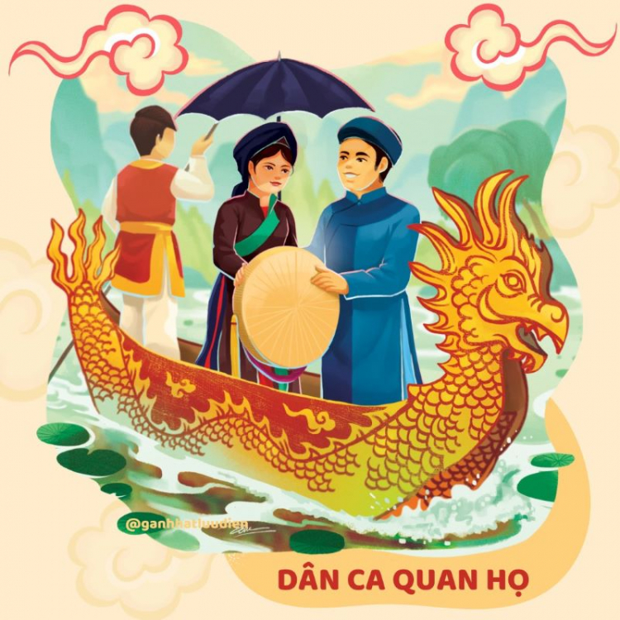

https://docs.google.com/document/d/1UnzQZjwIhqUc82Ssa8RkW7u63UHNbbK6KKLQh60yYOY/edit?tab=t.0

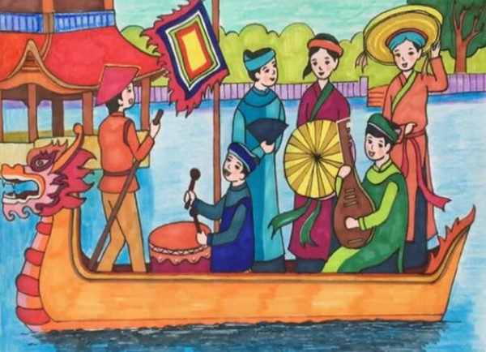

<https://thuthuat.taimienphi.vn/tranh-ve-de-tai-le-hoi-75148n.aspx>

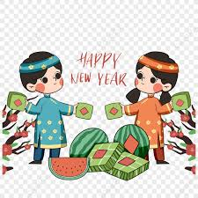

<https://vn.lovepik.com/image-380263181/cartoon-colorful-vietnamese-traditional-spring-festival-characters-plum-blossom-culture.html>

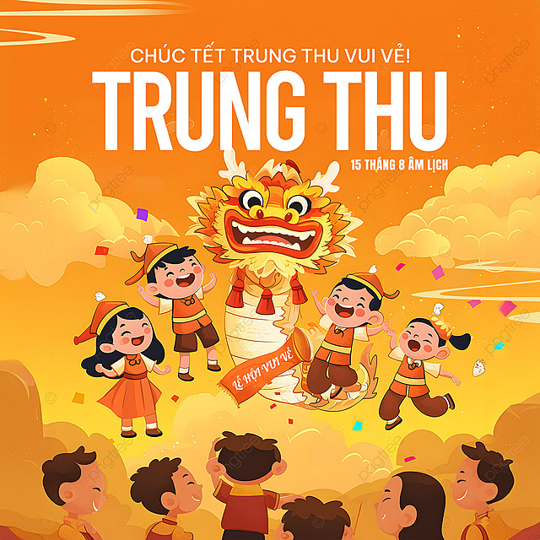

<https://vi.pngtree.com/freepng/cartoon-illustration-carnival-crowd-lion-dance-vietnam-mid-autumn-festival-holiday-blessing-social-media-advertising_16008925.html>

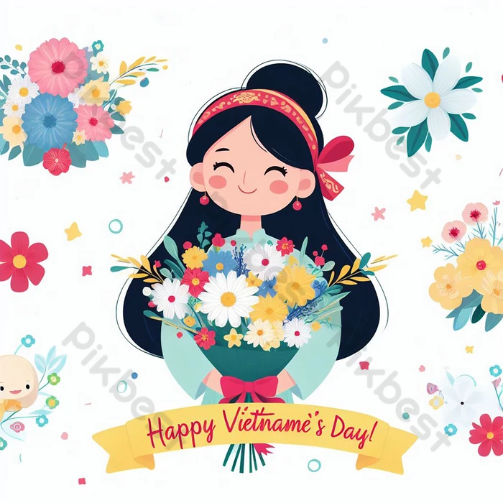

<https://vn.pikbest.com/templates/happy-vietnamese-womens-day-backgroundoctober-20-generated-by-ai_9566103.html>

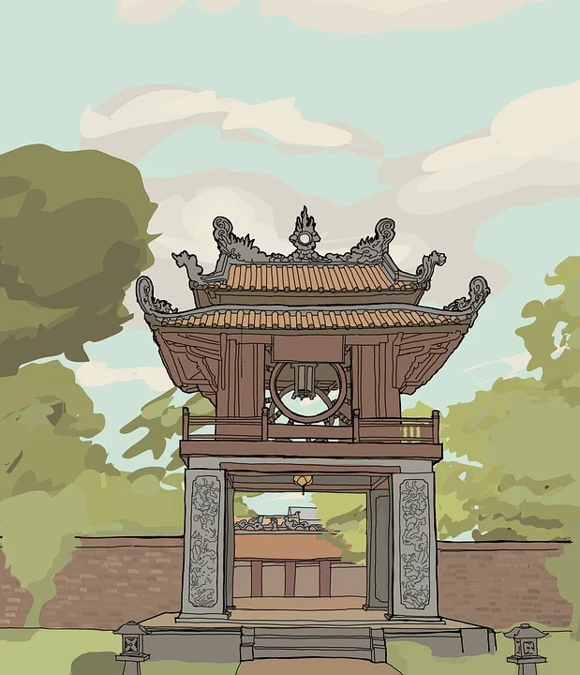

<https://pixabay.com/illustrations/confucius-vietnam-temple-hanoi-6314520/>

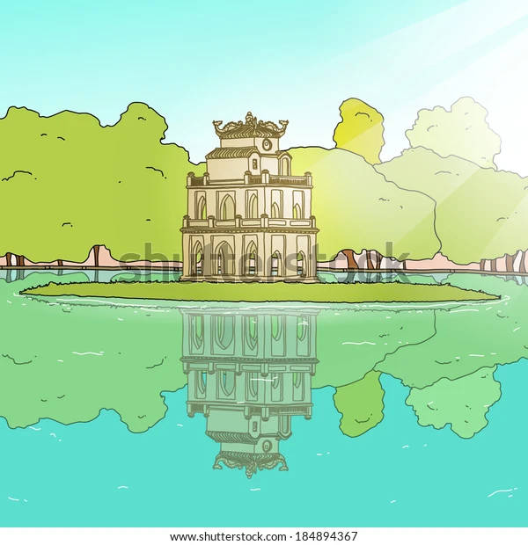

https://www.shutterstock.com/vi/image-vector/vietnamese-sword-lakeho-hoan-kiem-184894367



<https://vi.pngtree.com/freepng/vietnamese-tradition-womens-2d-illustration-art_15457787.html>



<https://idesign.vn/art-and-ads/rong-pham-chia-se-cai-kho-khi-ve-minh-hoa-su-viet-de-tai-nay-khoai-lam-hay-co-len-502439.html>

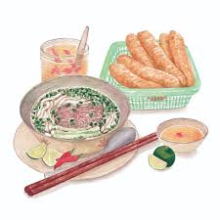

<https://cuoituan.tuoitre.vn/mau-pho-trong-tranh-minh-hoa-am-thuc-20221208092402934.htm>